**AL 1: Clarify what constitutes good**

**AD4: Ensure ongoing evaluation**



**LECTURER**

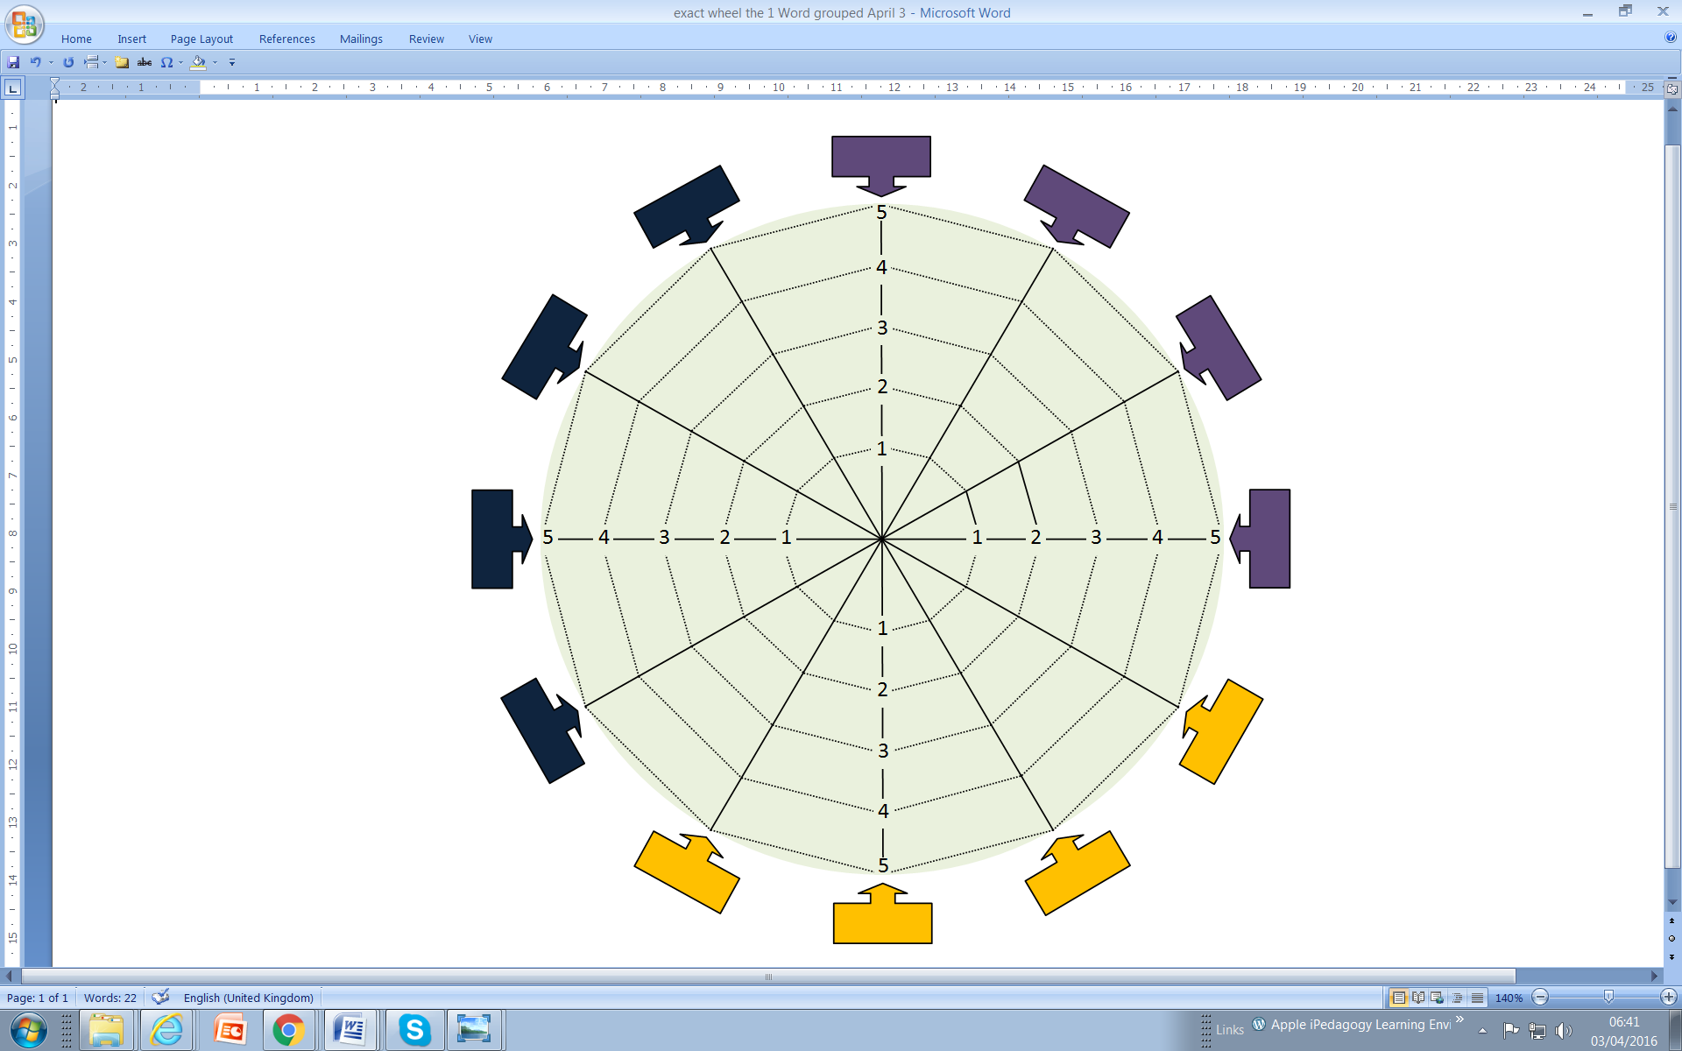

**AL 2 Clarify how assessment elements fit together**

**AL 3: Clarify student & staff entitlement**

**AL 4: Clarify the requirements of the**

**discipline**

**AD 1: QA literacy**

**AF 2: Provide early opportunities for students to act on feedback**

**AF 4: Promote development of students’ self-evaluation skills**

**AF 3: Prepare students for meaningful dialogue / peer engagement**

**AF 1: Provide accessible feedback**

**ASSESSMENT LITERACY**

**ASSESSMENT DESIGN**

**ASSESSMENT FEEDBACK**

**AD 2: Promote meaningful**

**and focused assessment**

**AD 3: Ensure access and equal opportunities**